**DISSTON E.S. - IEQ-BUILDING CONDITION EVALUTION SUMMARY**

***SUMMARY***

***• Active steam leaks were present in four [4] locations;***

***• Excessive moisture, dampness and condensation was documented in the school cafeteria and basement hallway areas;***

***• Chipping lead paint & damage to plaster was observed;***

***• Broken auditorium seats present a safety hazard to students;***

***• Water fountains function poorly or not at all with very little water pressure and it was reported that “brown water” backups in some water fountains and floor drains occurs during heavy rain;***

***• Very hot [~1900F] unprotected radiators were present in some areas reportedly resulting in burns to students; and***

***• Wiring [extensive cords] and power issues posing electrical hazard risk were observed***

**What PFTH&WF/U-H&S Did**

* We conducted a joint site visit with SDP-OEMS on 1/6/2016 pursuant to a request made to Dr. Hite’s Office by Councilman Bobby Henon.
* We inspected normally occupied areas of the main building.
* We interviewed educational staff & building engineering representatives about building conditions & environmental health impacts concerns.
* We documented visible conditions and took photographs in/of multiple locations.
* We discussed/provided recommendations for effective and timely response & remediation.
* We described follow-up approaches including ensuring recommendation implementation, data/information sharing & communication about findings and recommendations

**What We Found**

* Active steam leaks were observed in the cafeteria and underneath the “Girls-Side” & “Boys Side” stairwells as well as at the Schoolyard exit door near the “Girls Side”;
* The school building engineer reported that SDP steamfitters had repaired the leak in the Girls Side stairwell but our inspection document that there was still an active steam leak;
* Steam leaks have reportedly been present for “at least a few years”;
* Significant moisture, dampness and visible condensation was observed in the cafeteria and in the basement hallway;
* Significant damage to assumed lead paint on walls and ductwork was observed in stairwells, in the basement and in the cafeteria;
* Radiators in some classrooms with kindergarten and 1st grade students, as well as older children, were unguarded posing potential burn hazards. Staff reported that there had been “several” children burned by hot radiator surfaces;
* Significantly damaged flooring [wood and tile] was observed in the cafeteria around the diamond plate cover over the steam trench where active steam leaks were occurring;
* It was reported that there is only one [1] general cleaner for this 4 floor + Portable, 900 student/60+ staff school;
* Smart Boards installed in classrooms are only able to be powered by the use of school-purchased power strips &extension cords draped over the doorway and across walls in numerous classroom. This condition presents a potential electrical safety hazard

PFTH&WF/U Recommendations

• **Action Items include:**

***1) Immediately assess and repair all active steam leaks – ensure that a comprehensive evaluation has been conducted sufficient to identify all areas needing remediation;***

***2) Assess cafeteria flooring for mold presence and conduct remediation and flooring replacement as necessary;***

***3) Scrape and remove damaged lead paint from all surfaces in which it is chipping, peeling and deteriorated including, but not limited to, stairwells, duct work, cafeteria walls and ceilings. Lead safe work practices and procedures must be followed;***

***4) Immediately repair, and/or remove, damaged auditorium seating;***

***5) Assess the problem with water fountain pressure and effect necessary repairs so water fountains can be properly used;***

***6) Conduct an evaluation of reported plumbing system problems, issues and concerns to address and repair the water back-up problems that occur during heavy rain;***

***7) Assess the electrical/power needs for smart boards, computers and other electronic devices and the current use conditions and install additional outlets, properly designed electrical connections and/or provide additional power as necessary;***

***8) Assign additional cleaning personnel to the school – there is currently only 1 general cleaner in the building;***

***9) Provide & share the above information & data with PFTH&WF/U-H&S & other relevant stakeholders; and***

***10) Coordinate, schedule and conduct joint follow-up assessment and evaluation activities to facilitate verification and accountability of recommended implementation***

***Further evaluation and follow is required to protect occupant safety & health***

Selected Photos

**Photo 1: Disston E.S. – 01.06.2016 – Cafeteria – Condensation and Water on Overhead Support Beam – From Active Steam Leak**

**Photo 2: Disston E.S. – 01.06.2016 – Cafeteria – Damaged Floor – Area of Steam Leak**

**Photo 3: Disston E.S. – 01.06.2016 – Cafeteria – Damaged lead paint on wall**

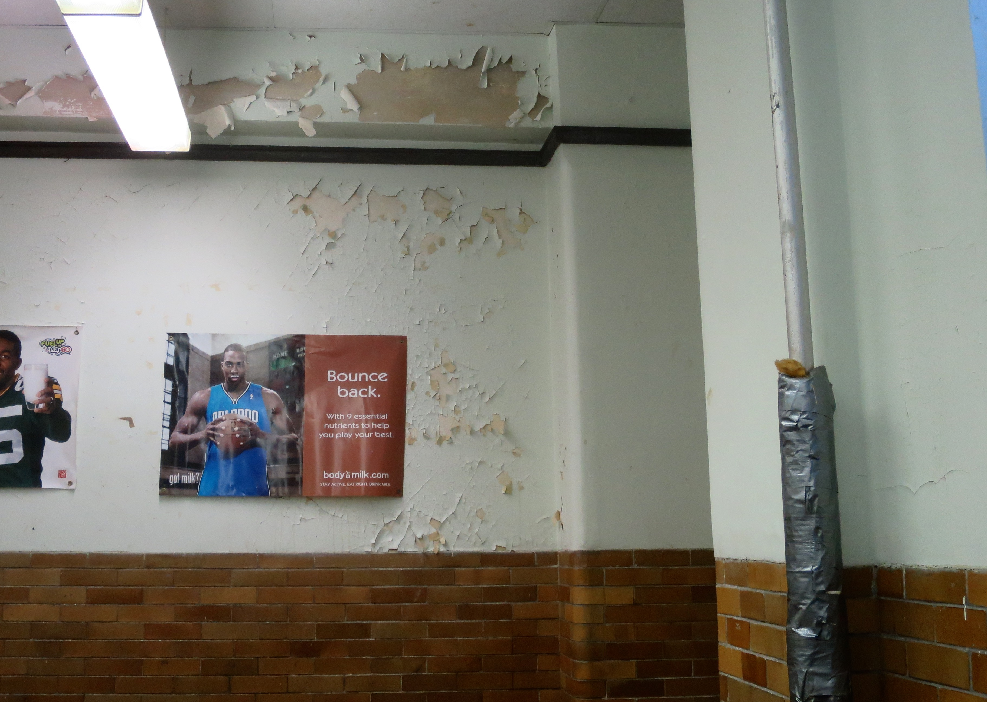

**Photo 4: Disston E.S. – 01.06.2016 – Cafeteria – Close up of Wall Damage**

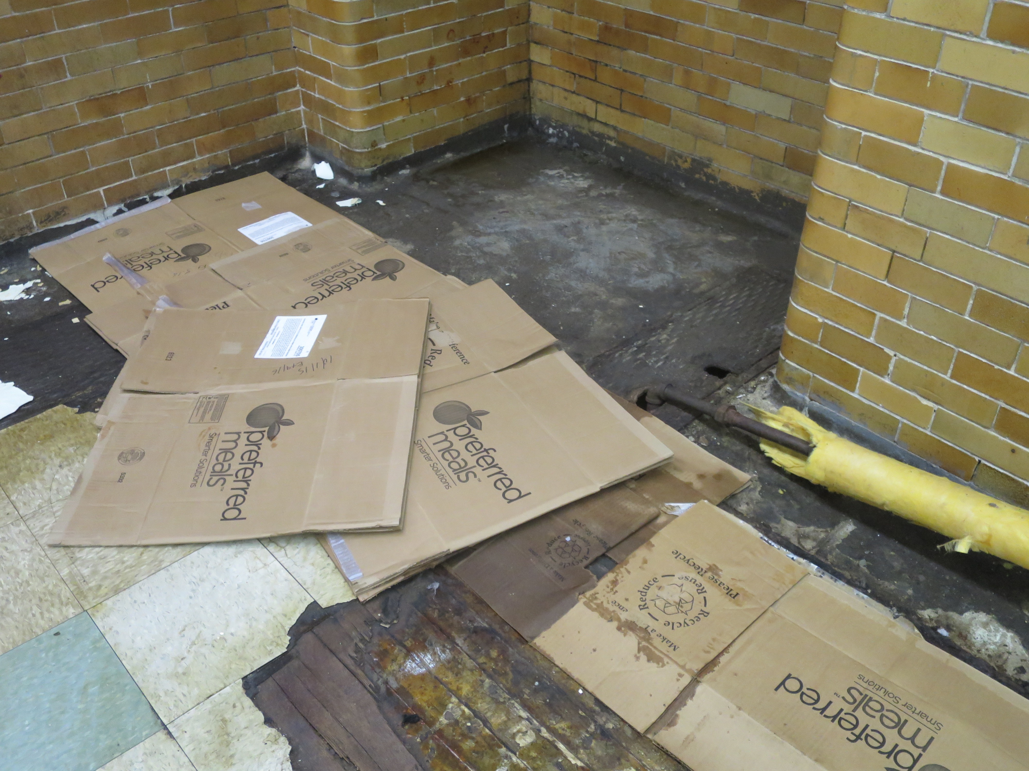

**Photo 5: Disston E.S. – 01.06.2016 – Cafeteria – Close up of Floor Damage**

**Photo 6: Disston E.S. – 01.06.2016 – Cafeteria – Detailed look at flooring – result of long term damage**

**Photo 7: Disston E.S. – 01.06.2016 –**

**Photo 8: Disston E.S. – 01.06.2016 –**

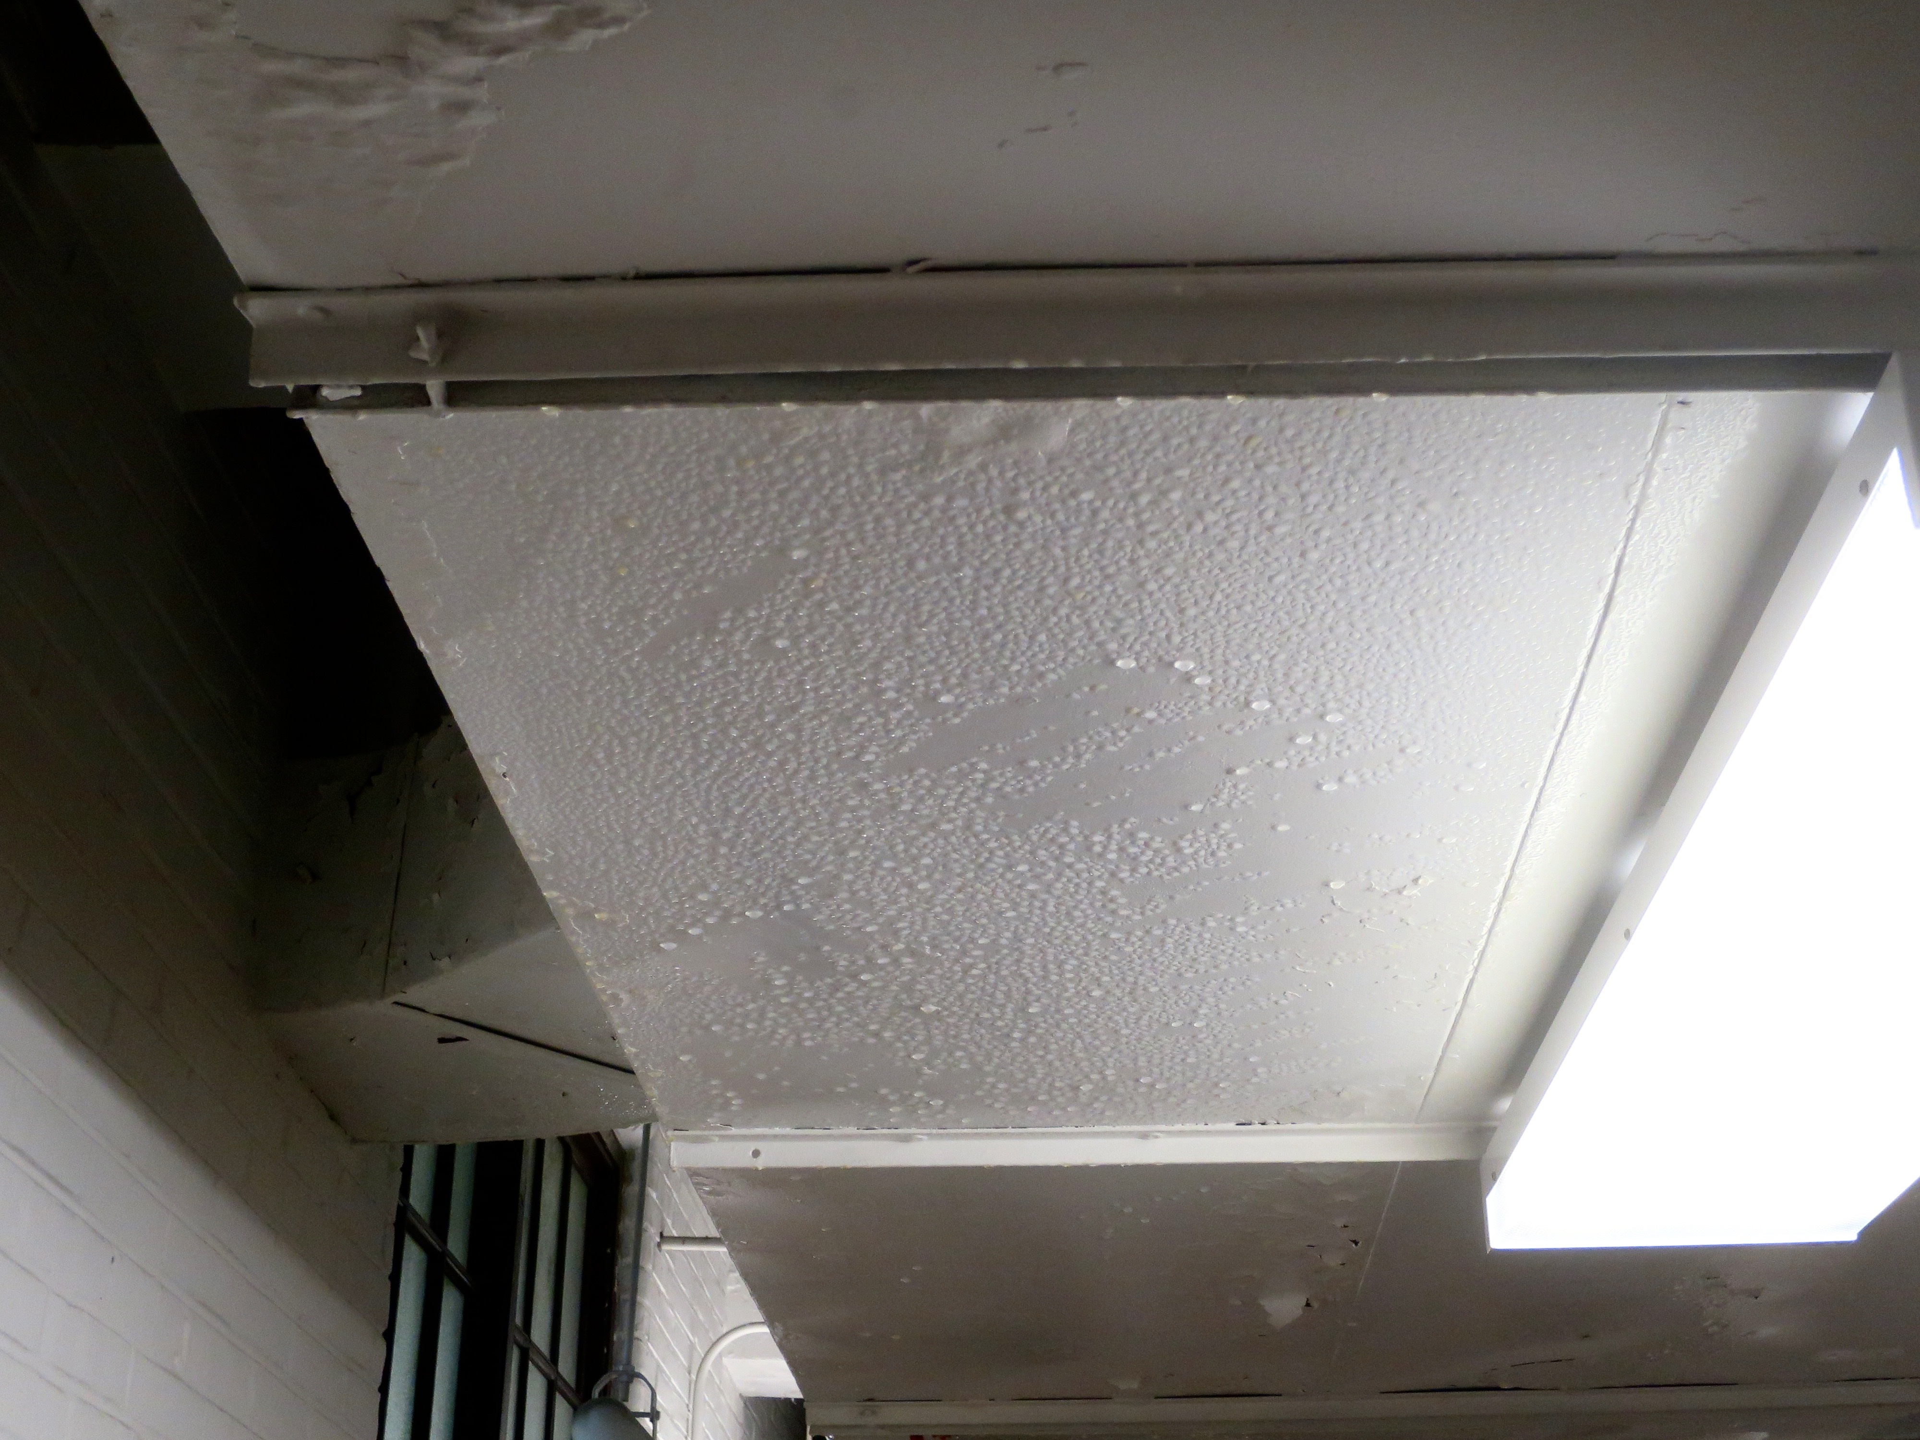

**Photo 9: Disston E.S. – 01.06.2016 –**

**Photo 10: Disston E.S. – 01.06.2016 –**

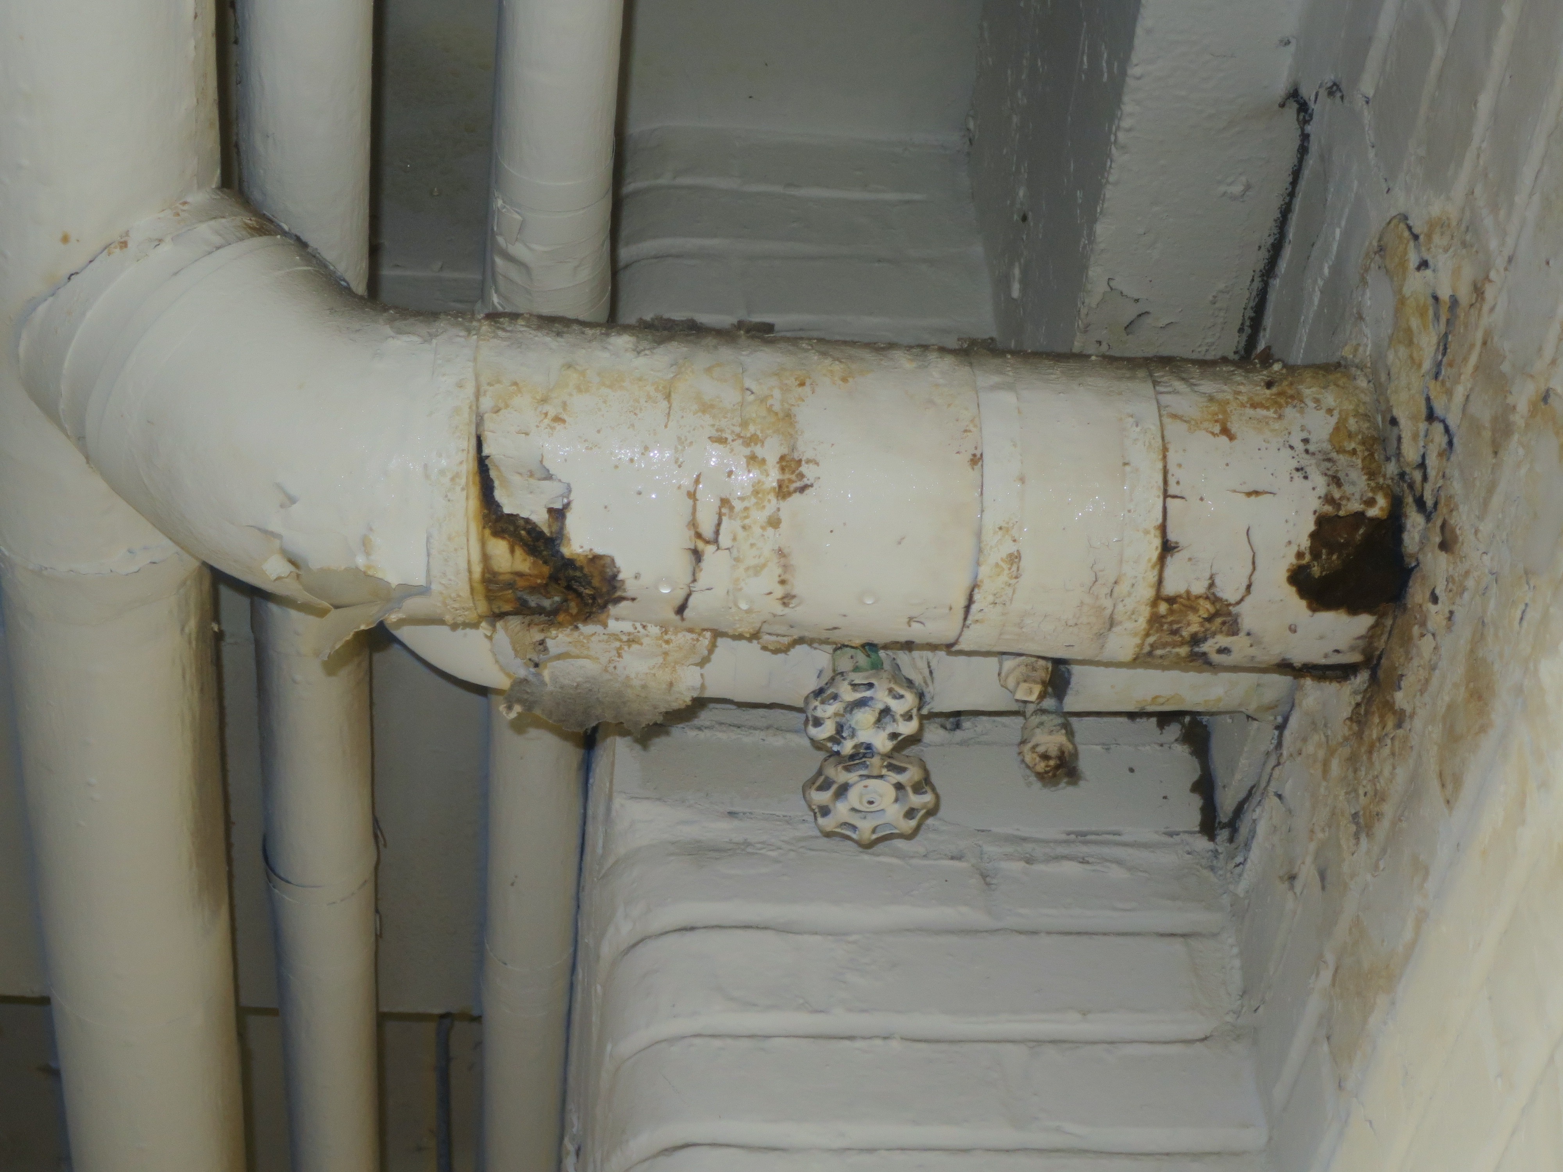

**Photo 11: Disston E.S. – 01.06.2016 –**

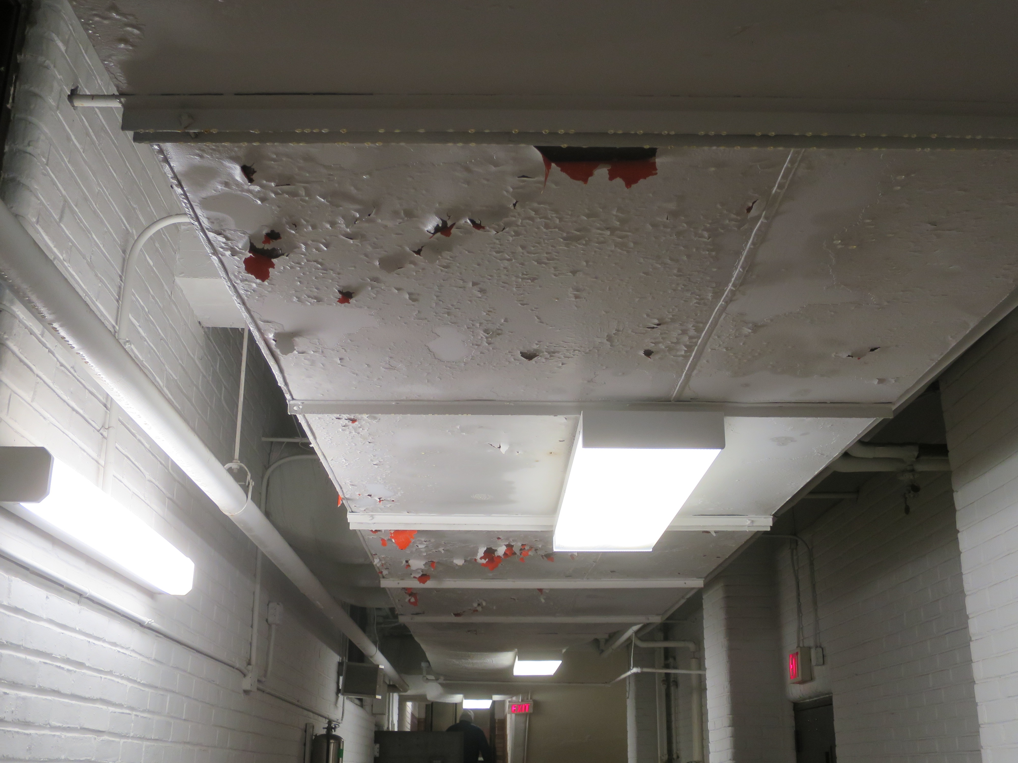

**Photo 12: Disston E.S. – 01.06.2016 –**

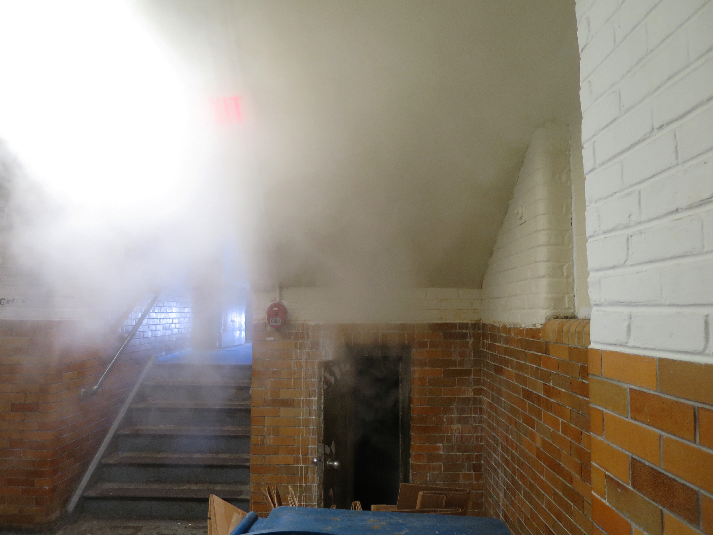

**Photo 13: Disston E.S. – 01.06.2016 –**

**Photo 14: Disston E.S. – 01.06.2016 – Room 103 – Power Cord for Smart Board**

**Photo 15: Disston E.S. – 01.06.2016 – Room 103 – Power Cord for Smart Board**